# SOURCE CODE FOR FCFS:

#include<stdio.h>

int main()

{

int bt[20], wt[20], tat[20], i, n;

float wtavg, tatavg;

printf("\nEnter the number of processes -- ");

scanf("%d", &n);

for(i=0;i<n;i++)

{

printf("\nEnter Burst Time for Process %d -- ", i);

scanf("%d", &bt[i]);

}

wt[0] = wtavg = 0;

tat[0] = tatavg = bt[0];

for(i=1;i<n;i++)

{

wt[i] = wt[i-1] +bt[i-1];

tat[i] = tat[i-1] +bt[i];

wtavg = wtavg +wt[i];

tatavg = tatavg +tat[i];

}

printf("\t PROCESS \tBURST TIME \tWAITING TIME\t TURNAROUND TIME\n");

for(i=0;i<n;i++)

printf("\n\t P%d \t\t %d \t\t %d \t\t %d", i, bt[i],wt[i], tat[i]);

printf("\nAverage Waiting Time -- %f", wtavg/n);

printf("\nAverage Turnaround Time -- %f", tatavg/n);

}

# Output:

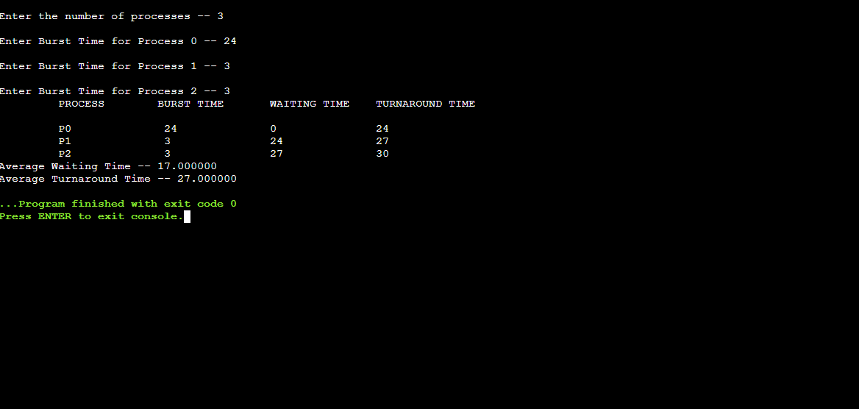

# Result:

# SOURCE CODE FOR SJF:

#include<stdio.h>

int main()

{

int p[20], bt[20], wt[20], tat[20], i, k, n, temp; float wtavg,

tatavg;

printf("\nEnter the number of processes -- ");

scanf("%d", &n);

for(i=0;i<n;i++)

{

p[i]=i;

printf("Enter Burst Time for Process %d -- ", i);

scanf("%d", &bt[i]);

}

for(i=0;i<n;i++)

for(k=i+1;k<n;k++)

if(bt[i]>bt[k])

{

temp=bt[i];

bt[i]=bt[k];

bt[k]=temp;

temp=p[i];

p[i]=p[k];

p[k]=temp;

}

# OUTPUT:

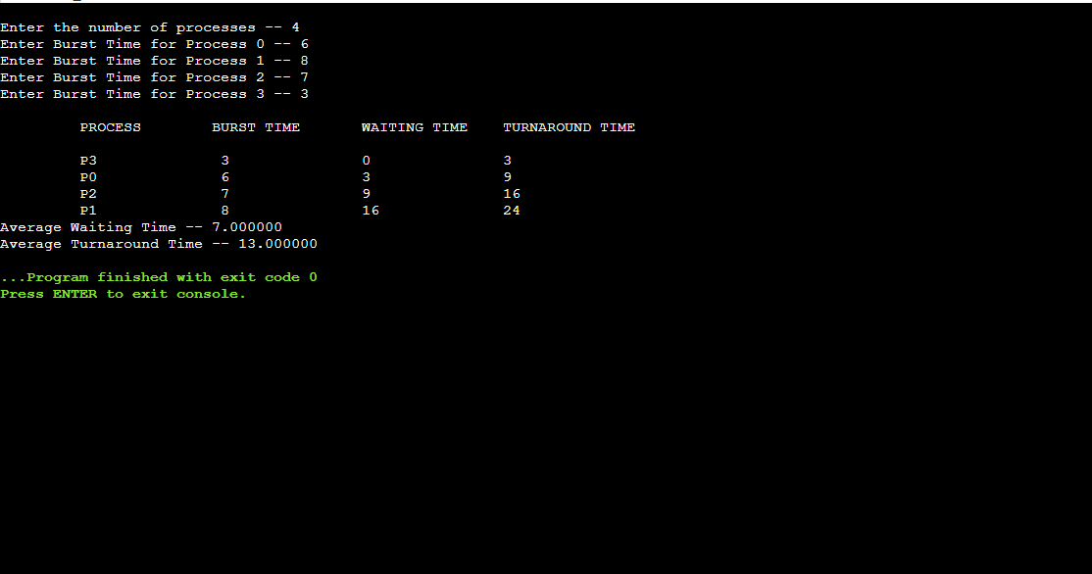

# RESULT:

# SOURCE CODE ROUND ROBIN:

#include<stdio.h>

int main()

{

int i,j,n,bu[10],wa[10],tat[10],t,ct[10],max;

float awt=0,att=0,temp=0;

printf("Enter the no of processes -- ");

scanf("%d",&n);

for(i=0;i<n;i++)

{

printf("\nEnter Burst Time for process %d -- ", i+1);

scanf("%d",&bu[i]);

ct[i]=bu[i];

}

printf("\nEnter the size of time slice -- ");

scanf("%d",&t);

max=bu[0];

for(i=1;i<n;i++)

if(max<bu[i])

max=bu[i];

for(j=0;j<(max/t)+1;j++)

for(i=0;i<n;i++)

if(bu[i]!=0)

if(bu[i]<=t) {

tat[i]=temp+bu[i];

temp=temp+bu[i];

bu[i]=0;

}

else {

bu[i]=bu[i]-t;

temp=temp+t;

}

for(i=0;i<n;i++){

wa[i]=tat[i]-

ct[i]; att+=tat[i];

awt+=wa[i];}

printf("\nThe Average Turnaround time is -- %f",att/n);

printf("\nThe Average Waiting time is -- %f ",awt/n);

printf("\n\tPROCESS\t BURST TIME \t WAITING TIME\tTURNAROUND TIME\n");

for(i=0;i<n;i++)

printf("\t%d \t %d \t\t %d \t\t %d \n",i+1,ct[i],wa[i],tat[i]);

}

# OUTPUT:

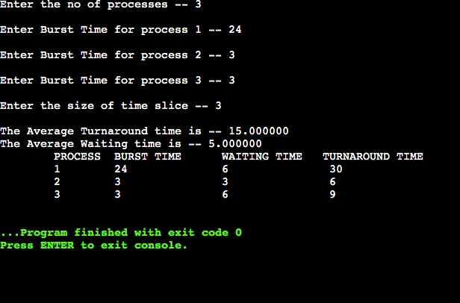

# RESULT:

# SOURCE CODE FOR PRIORITY:

#include<stdio.h>

int main()

{

int p[20],bt[20],pri[20], wt[20],tat[20],i, k, n, temp;

float wtavg, tatavg;

printf("Enter the number of processes --- ");

scanf("%d",&n);

for(i=0;i<n;i++){

p[i] = i;

printf("Enter the Burst Time & Priority of Process %d --- ",i);

scanf("%d%d",&bt[i], &pri[i]);

}

for(i=0;i<n;i++)

for(k=i+1;k<n;k++)

if(pri[i] > pri[k]){

temp=p[i];

p[i]=p[k];

p[k]=temp;

temp=bt[i];

bt[i]=bt[k];

bt[k]=temp;

temp=pri[i];

pri[i]=pri[k];

pri[k]=temp;

}

wtavg = wt[0] = 0;

tatavg = tat[0] = bt[0];

for(i=0;i<n;i++)

{

wt[i] = wt[i-1] + bt[i-1];

tat[i] = tat[i-1] + bt[i];

wtavg = wtavg + wt[i];

tatavg = tatavg + tat[i];

}

printf("\nPROCESS\t\tPRIORITY\tBURST TIME\tWAITING TIME\tTURNAROUNDTIME");

for(i=0;i<n;i++)

printf("\n%d \t\t %d \t\t %d \t\t %d \t\t %d ",p[i],pri[i],bt[i],wt[i],tat[i]);

printf("\nAverage Waiting Time is --- %f",wtavg/n);

printf("\nAverageTurnaround Time is --- %f",tatavg/n);

}

# OUTPUT:

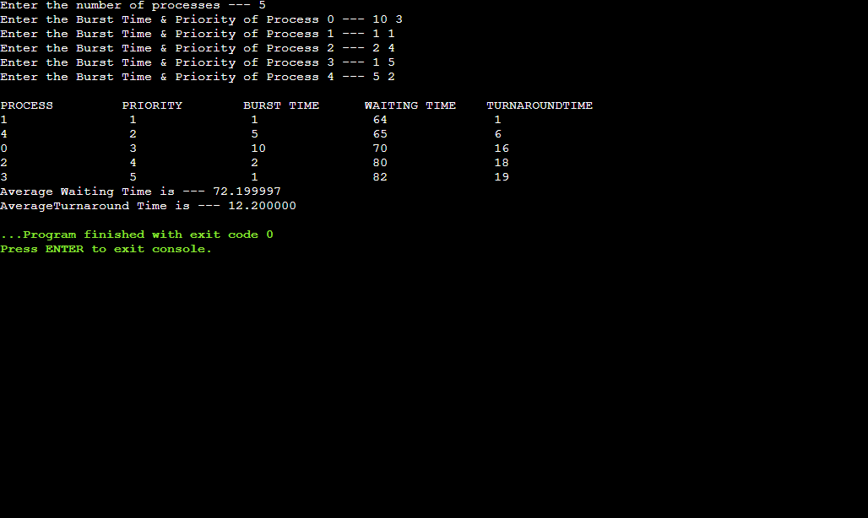

# RESULT: